Record No: 0678
VERE FRANCES DE MERLIE BELLINGHAM SOMERVILLE (Vere)

Of Boreham Manor, Warminster, Wiltshire

3rd dau of Bellingham Arthur Somerville (0631) by his wife Margaret Hall Clinch (0632).

Birth: 13 Jul 1890, at Friar’s Hill, Wicklow
Bapt: 1 Sept 1891,at St Audoen’s Dublin
Marriage: 14 Aug 1912,at Wicklow Church, to Lt Col Edmund Gray Stuart Truell (0679)
Death: 18 Apr 1976,at Camberley, Surrey,
Burial: Broadstone Cemetary, Nr Wimborne Dorest.

.

Source: Somerville Index

Notes: Vere was the mother of 10 children:
(1) de Merlie - - -(Merlie) bn 15 August 1913, md ? George Byas and was mother of Veronica
- - - , Patricia - - - and George - - - .Merlie d 27 August 1949
(2)Robert - - bn ? d 24 February 1919
(3)Joan - - - bn 1 March 1915, d 1 March 1919
(4)Rachel - - - (Ray) bn 21 November 1916, md ? Gordon Dewar and was mother of Alison - - -(Sally),Felicity - - -, James - - - and Susan - - -. Ray d ?
(5)Michael - - - bn 27 February md (1) ? divd ? md (2) Cazalet and was father of Peter - - and Angela Michael d 28 November 1967
(6)Charles Willliam Somerville (Toby) bn 22 May 1922 md ? Elizabeth (Beth) Moffatt-Wilson and was father of Jean - - -, Charles - - - and Zoe - - -. Toby d ??
(7)Frances bn and d 8 September 1925
(8)George - - - bn 11 July 1926 md ? Mary Fosbroke- Hobbs and was father of Edmund - - -, Daniel - - - and Sophie _d 20? _ _.
(9,10)Gillian and Joy (twins) bn 5 September 1929. Gillian md?John Gilmour and is mother of Angus---Virginia - -, ? , Frances - - - and David.Gillian d-- Joy md ?Raymond Goss (divd) and was mother of ? ? ? ? ? ? . She d ? .

For further information on Vere’s descendants, see the Truell Index and Pedigree.

Further research:

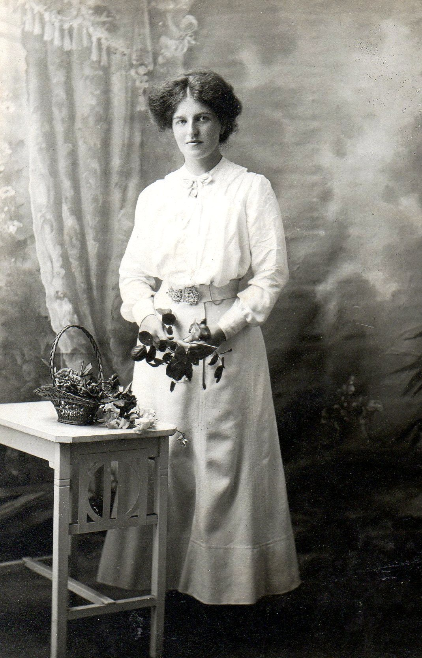

Note for David Gilmour from WBRBS.

I suggest that George Truell’s notes from the 1960s on his mother should be incorporated here, BUT there are uncertainties, inaccuracies and errors so the following should be approached with caution:
1 While I am aware of the family’s house in Harcourt St, Dublin, as far as I can see, the family lived in rented houses in and around Wicklow from 1888 to 1895 when, having bought Clermont the previous year and renovated it, they moved in. The idea that BAS lived in these rented houses on his own, except when babies were being born, is unrealistic. BAS, in his office journal, is scrupulous in entering up the various duties and time taken on them, and his absences on leave. It is true that he visits Dublin fairly frequently on 12 hrs leave of absence, but I take it that this is not to visit wife and children, so much as parents, and brother and to follow up his endless genealogical research. As far as I can see, they were at Seaview in 1888, Friars Hill 1890 – 1892, Ballyhenry 1894 and again at Seaview in 1895 before going to Clermont. On looking at George’s notes on BAS, there seems to be doubt about the time the family lived in Dublin. There he suggests they went to Harcourt Street in 1887. They were in Queenstown until the end of 1887 and then in Seaview in 1888, while he says here that they went to Harcourt St in 1892 so Georges two accounts don’t reconcile. I am pretty sure the period in Harcourt Street was 1892 to 1894 when, having bought Clermont, they returned to Wicklow, to Ballyhenry. Further enquiry needed; I must have letters.
2 There is a ref to the sale of Ballyhenry to raise death duties by The Rev WHA Truell. This is not correct. The doctor, Henry Pomeroy Truell, who had Clonmannon before his cousin,The Rev WHAT, had married Elizabeth Rolleston-Spunner,, grand daughter of a John Richards, of the Court of Exchequer.She looked after her two Richards cousins, Charles William and Ida at Clonmannon. My father had been led to believe that there was a question over the legitimacy of one or both of them. He said that Charles William, known as Billy Richards, behaved oddly and certainly looked odd; his two eyes were each of a different colour. He used to come to Clermont and would leave his wife in the car while he came in and was entertained. He had married Kathleen Stamper from NewtownMtKennedy in 1904 whereupon, they moved into Ballyhenry which was, in due course, transferred by voluntary transfer to them. I knew Kathleen Richards, as a fairly elderly lady; she was still at Ballyhenry when I was growing up and lived there with her widowed daughter, Joyce Brown (whose husband was killed in the Spanish Civil War) and her daughter Bumble (otherwise Noreen but later calling herself Loretta). There were childrens’ parties. In due course, Bumble was at TCD with me. There lies another story; she was sadly killed in a car accident shortly after making a ‘joke’ will in the TCD library, in which she left her estate, including Ballyhenry which her grandmother had transferred to her, all on various ‘amusing’ conditions; the tabloids had a field day.
3 The field backing on to the side lane (the Bullock Walk) at Clermont, and between it and the straight garden path, was called KEOGH’s Field.
4 The reference to Mr Tombe was to Bergie Tombe. He was the Tighes’ Agent at Rossana and, along with Dr Lyndon, was one of the few people regularly entertained at Clermont. He lived at Rossana Cottage, where Manon and I lived when we were first married, now, somewhat pretentiously called ‘The Dower House’ which it never was.
5 Jim was the first person in the family to have a car, I think, a de Dion Bouton ?, not sure of the second word.
6 The pitchfork incident is unknown to me; Pat was 17 and Regi was 14 rather too mature ? to be fooling with pitchforks, and if his boot and foot were really pierced, not to be forgotten by Regi. The two were very close throughout their lives.
7 Uncle Tom Rolfe was the Rector or Vicar of Kirk Bramwith in Yorkshire, The Rev PB Johnson was Rector of Wicklow.
8 The ‘CLADDAGH’ was a waterside settlement in Galway said to be as old as the Armada. It is part of Irish history that many Spaniards were washed up in Galway B
ay; in fact most of them were washed up further north around the Donegal coast. They are often said to be responsible for the dark haired Celtic stock. The description of the ring is accurate, but I wasn’t aware it served as a wedding ring, though this seems reasonable.
9 Keenagh Hill is, I think, the property more recently called the Khyber Pass; it is situated at the top of a cliff above the railway line.
10 I don’t know of a Maine House in or near Wicklow; I wonder is somebody misreading Marlton House.
11 Ballyvolan is near Newcastle, not near Ashford.

For David Gilmour.

I hesitate to write about your grandmother, especially as I have few detailed memories of her.

What I do recall is that she was a ‘difficult person’, both in her own family and in the wider family. She always seemed to be at odds with one or more of her children; particularly Toby and Ray. I had experience of her refusal to talk to members of her family at Tetty’s funeral which I had to arrange. She would not go in the same car as Ray from the Church to Putney vale, so there was a row as to who would go in which car – I don’t now remember the detail, but she really was impossible at the time. Her infrequent visits to Ireland were approached with concern, if not dread, by the family here, so much so that we discouraged her from attending my father’s funeral for fear of a scene. On the other hand, when she came to Cecil’s funeral, I think that was the time, she came here to see us accompanied by Mary, George’s wife; she was sweetness itself on that occasion.
Please see the notes written by George Truell in the 1960s about his mother in the Truell Index, No 81.

27 Dec 1906 uncle Alan Somerville died
5 Mar 1895 sister Dorry died
14 Aug 1912 married Edmund
15 Aug 1913 daughter Merlie born
14 Feb 1915 uncle Henry Somerville died
1 Mar 1915 daughter Joan born
16 Jan 1916 father died
21Nov 1916 daughter Ray born
10 Mar 1917 uncle Billy Somerville died
24 Feb 1919 son Robert died
1 Mar 1919 daughter Joan died
27 Feb 1920 son Michael born
22 May 1922 son Toby born
8 Sept 1925 daughter Frances born & died
11 Jul 1926 son George born
5 Sep 1929 Twin daughters Gillian and Joy born
10 July 1947 brother Pat died
5 July 1949 mother died
27 Aug 1949 daughter Merlie died
13 Apr 1950 brother Jim died
3 May 1950 husband Edmund died
13 Feb 1951 brother Bunt died
1967 son Toby emigrated
28 Nov 1967 son Michael died
22 July 1971 brother Regi died
8 Apr 1973 sister Edeline died
17 Aug 1973 sister Cecil died

Vere outlived all her brothers and sisters; two of her children died within 8 days of each other in the flu epidemic following the Great War, a third daughter only lived for a few hours. Vere also outlived
her daughter Merlie and her son Michael and
following his emigration to New Zealand never saw
her son Toby again.

